# Introduction

*[State what your research/project/enquiry is about. What are you writing about, why and for whom? What are your objectives? What are you trying to show or prove (your hypothesis)?]*

In agriculture, irrigation is an essential process that influences plant growth. Irrigation of plants is usually an important activity. Traditionally, all these steps are executed manually by humans. Currently in developing countries, some companies use basic systems to reduce the number of workers or the time required to water their garden plants. With such systems, the control is limited, and many resources are still wasted.

Today agriculture uses 85% of water for irrigation purposes only. This percentage may increase because of increased population growth and food demands. Thus water

shortage is one of the problems in the world. Today most efficient plant monitoring systems are occurring day by day by using optical and IR images of plants. Water is essential for every human being, animal and plants. It is also a basic need for every human being . The wastage of water is the major problem in most of the agriculture. This can be reduced by using different methods developed for conservation of water.

# 

# Methodology

*[State how you did your research/enquiry and the methods you used. How did you collect your data? For example, if you conducted a survey, say how many people were included and how you selected them.]*

An automated irrigation system needs to be developed to optimize water flow for agricultural crops. An intelligent automatic irrigation system has to have all the components that automatically monitor and control the level of water available to the plants with very minimal human intervention. We want to develop a system which can be powered by a battery to operate the water pump which can switch on or off automatically depending on the soil moisture level of the crops in the respective fields.

The automatic system should perform the following functions:

* Continuously monitor the amount of soil water available to the plant based on the soil type.
* Determine if watering is required for the plants.
* Monitor the water level of the water storage.
* Supply the exact amount of water required for the crops.
* Turn off the water pump when the required amount has been delivered to the plants.

Our proposed system is designed in such a way that it continuously monitors the moisture level of the soil. The system responds accordingly when the moisture level is low by watering the soil with the exact amount of water needed if enough water is available in the water storage that is used and then turning off the water supply when the required level of soil moisture is attained.

Most of our research was literature review of relevant works.

During design phase, we did a small experiment before implementing the system to calibrate the sensor by recording 2 hr of soil moisture readings to the EEPROM of the microcontroller. At the 1 hr mark, the soil was irrigated with approximately 200 mL of water.

# Procedures

*[State the processes you followed, describe everything you did, you planned to do, etc.*

*Simulations, Diagrams, Codes, Circuit & other relevant Details should be incorporated.]*

We took this project in three distinct phases:

* **Proposal phase:** Determine an appropriate problem and its possible solutions.
* **Discussion phase:** Define functionality, requirements, features, and feasibility.
* **Design phase:** Produce the project designs, logic, diagrams, and report.

## Proposal phase

Initially, we collected examples of microprocessor-based projects that ranged in complexity from simple (e.g. blinking LEDs) to advanced (e.g. wireless communication, sensing, etc.) from various sources. These sources included:

* **Generic searches on YouTube.** We used terms such as “arduino project”, “microcontroller project”, “microcontroller tutorial”.
* K. Keane, A. Ringler, M. Vrablic, and A. Gandhi, **“Collaborative Design and Creative Expression with Arduino Microcontrollers,”** MIT OCW, 2017, (Student Projects), <https://ocw.mit.edu/resources/res-3-002-collaborative-design-and-creative-expression-with-arduino-microcontrollers-january-iap-2017/student-projects/>
* M. Gajamohan, M. Muehlebach, T. Widmer and R. D'Andrea, **"The Cubli: A reaction wheel based 3D inverted pendulum,"** *2013 European Control Conference (ECC)*, 2013, pp. 268-274, [doi: 10.23919/ECC.2013.6669562](https://doi.org/10.23919/ECC.2013.6669562).
* D. Ibrahim, **“ARM-Based microcontroller projects using MBED,”** Elsevier Ltd., 2019, [doi: 10.1016/C2018-0-02627-4](https://doi.org/10.1016/C2018-0-02627-4)

We organized a team meeting of 2 hr duration to talk about the intended purpose of the lab project, and likely ideas and goals. We set up a shared folder for collaboration and made a brainstorming document to write down favourable ideas that we had collected or come up with. We also wrote down lists of sensors and actuators at our disposal to have a clear sense for the capabilities of a microcontroller system. The final list is shown below:

**Note 1.** Proposal planning document

| **Topic:** Home lifestyle  Ideas:   * Solar panel water garbage collector * Automatic garden irrigation system * Smart shopping trolley with automated billing system * Alzheimer’s assistant smart watch * Automated car parking with empty slot detection * Carbon monoxide detector * pH, turbidity level detector and aquatic life counter * Automatic liquid dispenser   Household appliances:   * Calculator * Clock * Smart light   Sensors:   * Buttons * Capacitive touch sensor * Light sensors * Infrared light sensors * Sonar (distance measurement) * Camera * Motion sensor * Temperature sensor * Humidity sensor * PotentiometerAccelerometer * Gyroscope * Magnetometer * Weight sensor * Electret microphone   Actuators:   * Displays * LEDs * Infrared LEDs * Laser diode * Pumps * Submersible pump * Motors/Fans * Digital lock * Servo (aka stepper motor) + Driver circuit (controls power/communication) * DC Motors (aka rapidly spinning) + Driver circuit (controls power/communication) * Vibration motor * Muscle wire actuator * Buzzer |
| --- |

At the end of the meeting, we decided on the **automatic plant irrigation system** idea, and concluded our planning phase.

## 

## Discussion phase

We found many aspects and specific details that were to be discussed for the microcontroller project within the discussion phase.

At the beginning, we mostly looked at other implementations and shared details and papers via text communication. Once we had some background information, a team meeting of 2 hr was held to discuss the specific details.

We made a discussion document and clarified details by repeatedly following these steps:

1. Propose a question
2. Figure out possible solutions
3. Find relevant literature

Most of our discussion was verbal, and we have no record of it since we did not assign a [minute-taker](http://www.free-management-ebooks.com/faqmt/minutes-03.htm). However, we generally followed the above steps and also reviewed a research paper on drip irrigation together.

**Note 2.** Logic design document

| Background  Goals:   1. Maintain a plant without human presence for at least 1 week 2. Checking the soil humidity.   Memory constraints:   * SRAM -> 2K * EEPROM -> 4K * Flash -> 4K-64K   When should a plant be irrigated?   * Timer based: Morning, Evening * <https://extension.arizona.edu/sites/extension.arizona.edu/files/pubs/az1392-2016_0.pdf>   Alerting when?   * Sensor fault * Tank is empty/Main line being used * Soil too dry * Soil too humid -> Overflow/Not draining   Alert how?   * Beeper * Screen message   Water supply method   * Gravity tank * Pump-based * Main line * **COMBINED?**   + Tank preferred, if empty then use main line   + Gardener then doesn’t need to be alerted   Irrigation method   * Morning/evening watering * Drip irrigation   Soil humidity regulation methods   * Fixed duration/quantity * Threshold * Feedback loop   Ideal soil humidity   * Calibrate soil humidity by watering the plant manually once   Features   * Maintain time of day * Measure sensors:   + Soil humidity   + Light sensor   + Temperature   + Air humidity   + Clock * Control: Push buttons    + 4x buttons (back,select,left,right)   + Main menu logic   + Selected option is highlighted on screen * Screen:   + Water levels   + Temperature   + Alert type: Overflow/Tank empty/Main line switched/Sensor malfunction   + Beeper   + Red/Green/Blue LEDs * Irrigation scheduling:   + Algorithms to decide when to water the plants   + Timer (morning/evening)   + Light sensor to detect day/night cycle   + Threshold on soil humidity sensor * Irrigation control:   + Solenoid valves: <https://bc-robotics.com/tutorials/controlling-a-solenoid-valve-with-arduino/>   + Pump: <https://arduinogetstarted.com/tutorials/arduino-controls-pump>   + Pressure regulators: ... * Alert detection   + When: Sensor fault/Tank empty or overflow/Humidity out of bounds   + How: Screen/LED/Beeper |
| --- |

With many of the major decisions made, we concluded the discussion phase.

## 

## Design phase

We made some modifications to the ideas made in the last discussion to limit the scope of the project and avoid several constraints inherent with the Arduino board, including but not limited to:

1. Availability of digital/analog GPIO pins
2. Power limitations from GPIO pins
3. Practical usability concerns
4. Design concerns

Due to (1), we could not fit audio buzzers, a water level sensor, alerts, and water flowmeters.

Due to (2), we used the knowledge that each GPIO pin is limited to supplying 20 mA, and all of the pins together are limited to supplying 200 mA. Since the motors were the only peripheral that required significant current, we added transistors and relays to the design to switch the pump motors.

Due to (3), we replicated the plant sensors and actuators four times, so that one single microcontroller system can monitor and maintain four plants at the same time.

Due to (4), we were limited by the fact that our simulation software (Tinkercad) cannot simulate pumps or solenoid valves. We used DC motors to model the pumps but did not find an equivalent for valves.

An alternative and better design would be to have one single pump connected to four solenoid valves which pipe water to the plants. However, we did not find any way to demonstrate our system in this manner, since we would not be able to show the solenoid valves opening and closing. Thus, having four pumps and no solenoid valves was taken as a design compromise.

[Circuit diagram: System layout]

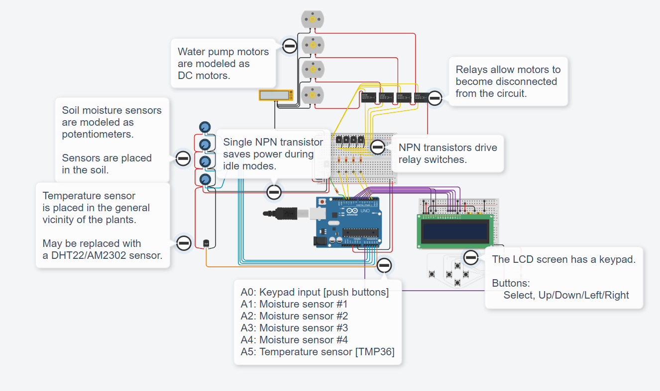

[Code]

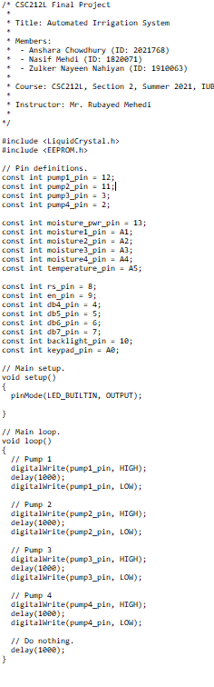

[Logic diagram: System-level block diagram]

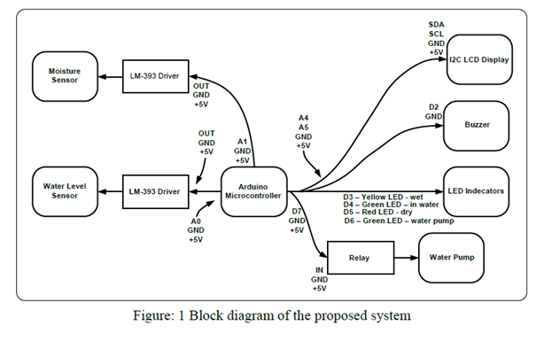

[Class diagrams:

* Plant
* Soil
* Schedule
* Display
* Menu
* BaseController
  + IrrigationController
  + MenuController
* BaseActuator
  + PumpActuator
  + BuzzerActuator
* BaseSensor
  + TemperatureSensor
  + HumiditySensor
  + MoistureSensor

]

# 

# Findings/results

*[Give the results of your research. Do not, at this stage, try to interpret the results – simply report them. This section may include graphs, charts, diagrams etc. (clearly labelled). Be very careful about copyright if you are using published charts, tables, illustrations etc.]*

# Discussion

*[Interpret your findings. What do they show? Were they what you expected? Could your research have been done in a better way?]*

# Conclusions and recommendations

*[These should follow on logically from the Findings and Discussion sections. Summaries the key points of your findings and show whether they prove or disprove your hypothesis. If you have been asked to, you can make recommendations arising from your research.]*

There are many techniques to control or save the wastage of water. The first one is the ditch irrigation scheme, where the ditches are dug out and seeds are planted in a row. There are

tubes like siphon tubes are used for the movement from the main ditch to the canals. Drip irrigation is also the most efficient method for irrigation; in this the water drops at the root zone of the plant in a dripping motion [5]. Sprinkler system is also an irrigation based system, where sprinklers, sprays or guns are on the tubes. The water flows through the tubes and at some ends there are sprinklers to sprinkle the water in those areas. The sprinkler will be activated only when the temperature and humidity sensor at the root zone exceeds the threshold value.

# References

[1] W. A. Jury and H. J. Vaux, 2007, “The emerging global water crisis: Managing scarcity and conflict between water users”, Adv.Agronomy, vol. 95.

[2] X. Wang, W. Yang, A. Wheaton, N. Cooley, and B. Moran,2010, “Efficient registration of optical and IR images for automatic plant water stress assessment”, Computers and

Electronics in Agriculture, vol. 74, no. 2, pp. 230–237..

[3] G. Yuan, Y. Luo, X. Sun, and D. Tang, Jan. 2004, “Evaluation of crop water stress index for detecting water stress in winter wheat in the North China Plain”, Agricultural Water Management, vol. 64.

[4] <https://www.researchgate.net/publication/283230079_Implementation_of_an_automated_irrigation_system_Smart_irrigation_system_paper_subtitle>

[5] https://www.researchgate.net/publication/336254022_Using_Arduino_Based_Automatic_Irrigation_System_to_Determine_Irrigation_Time_for_Different_Soil_Types_in_Nigeria